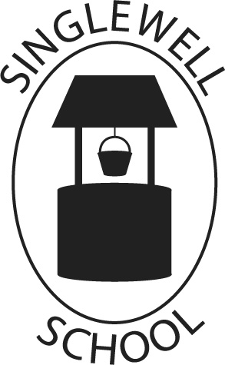

Homework Policy

Adopted and Approved by the Governing Body: November 2022
Review Date: November 2026

Signed: -------------------------------------- Date: ------------------------
Chair of Governors

Signed: -------------------------------------- Date: -----------------------
Headteacher

Homework Policy

At Singlewell Primary School, children are assigned homework based on what they have learnt that week. In these tasks, pupils are given the chance to practise and apply their knowledge independently. Each homework activity is designed to take around 10-30 minutes. Pupils should already be familiar with the content; the time spent completing their homework is an important opportunity to consolidate their learning. Homework frequency varies depending on the age of the pupil.

Homework should:
- Help to develop a partnership between home and school, between the ages of 4 – 11 whilst a child is at Singlewell Primary School.
- Teachers recognise that homework has a greater success when it is valued by pupils and parents.
- Promote sensitive and supportive approaches to learning which can be implemented by the parents in the home environment.
- Introduce children to individual study and homework at the primary stage to prepare them for the later stages of education

 | Reception | Year 1 | Year 2 | Year 3 | Year 4 | Year 5 | Year 6
Reading
Spellings |  | Weekly from Term 2 | Weekly | Weekly | Weekly | Weekly | Weekly
Maths |  | Every other week | Every other week | Every other week | Every other week | Weekly | Weekly
In addition to the above tasks the children will have online activities to complete on Purple Mash and Times Tables Rockstars.
Over the course of the year children may have projects to complete in relation to their topics. This may be in the form of research, models, experiences etc.

Homework tasks can be broken down as follows:

Reception
- Children will take books home for shared reading to enable parents to encourage children to read every day with a book they have read, a book they are reading and a book for pleasure.
- Weekend news
- Arts and crafts
- Letter and number formation

Year 1 and Year 2

- Children will take books home for shared reading, enabling parents to encourage their child to read every day. It can be with a book they have read, a book they are reading and a book for pleasure.
- Parents are encouraged to help children to practice their phonics, letter recognition, simple spellings, number bonds, money and telling the time.
- Weekly homework will alternate between Maths and English
- Spellings once a week.
- Purple Mash
- SATs practice nearer the time.

Year 3 and Year 4

- Daily reading of a range of texts
- Weekly homework will alternate between Maths and English
- Children will regularly have spellings, number bonds and tables to learn.
- Children may be asked to complete individual research into class topics related to the curriculum.
- Comprehension
- Purple Mash/ TTRS

Year 5 and Year 6

- Homework tasks are made relatable to their current learning where possible so learning from school can be reinforced.
- Daily reading of a range of texts
- Independent homework is encouraged and rewarded with house points
- Maths
- Comprehension tasks
- Weekly spellings
- Purple Mash/ TTRS
- Children will be asked to complete individual research into class topics related to the curriculum.

Partnership with Parents

The School needs to be able to count on parents’ support and the School needs to keep parents informed so that the homework process can be most effective. Homework books and reading records are to be used as a form of communication between parents and teachers to ensure consistency and so that homework is a valuable experience.

