HOMEWORK FOR CHILDREN DURING SCHOOL CLOSURE
In order to provide continued opportunities for learning we have enclosed some suggestions for each year group to do.
These are activities that are linked to the children's current work at school. Please let your child do whichever activities that appeal to them. If the children complete their own tasks or would prefer to select a task from another year group, they are most welcome to do so.
On their return to school the teachers would be delighted to see any homework tasks that the children would like to share with their class.

YEAR R HOMEWORK

Our topic this term has been 'Growing'

Imagine a giant beanstalk grew in your garden! Draw a picture and write about what you would like to find at the top of your beanstalk!

The beanstalk was very tall. Can you find 5 things in your house that are taller than you and 5 things that are shorter than you?

Can you draw a life cycle of a plant? Can you label your life cycle?

Try making a model of a flower. You could use playdough, paper/card, construction toys or junk modelling. Think about how you could make the stem, the flower and the leaves!

Draw or paint a picture of some flowers. What colours do you need? Can you label the different parts of a flower?

Can you make your own storybook of Jack and the Beanstalk? Can you draw the pictures and use storytelling language, such as ‘Once upon a time’, ‘One day’, ‘the next morning’, ‘the end’.

Continue reading books from the wish list and your reading book from school!

Here are some useful websites for maths and phonics:

https://www.bbc.co.uk/cbeebies/shows/numberblocks
https://www.topmarks.co.uk (search for: early years, phonics, or maths)
https://www.phonicsplay.co.uk/
https://www.phonicsbloom.com/
https://www.bbc.co.uk/cbeebies/shows/alphablocks

YEAR 1 HOMEWORK

Read as many books off your wish list as you can and answer the following questions about one of the books:
What is the setting?
Who are the characters?
Why do they like the book?
What happens first/next/last?
What would you change about the book?

Make a list of your number bonds to 10 and 20
Create your own alien. Can you describe your alien in detail using exciting adjectives?

Research and create your own poster about the Solar System.

Build your own Solar System using junk modelling or playdough.

Watch Sir David Attenborough’s Blue Planet find out all about animals and our amazing Earth. Can you create a fact file?

Complete some Mathletics tasks and practise counting in 2’s, 5’s and 10’s.

Visit the phonics play website https://www.phonicsplay.co.uk/Phase2Menu.htm and play some phonic games.

Read your daily reading book with an adult and remember to fill in your Reading Record to get more raffle tickets.

YEAR 2 HOMEWORK

Our topic this term has been 'Kings and Queens'

Maths - Complete multiplication and division activities from Mathletics.
Carry on practicing the column method for adding and taking away.
Use the bar model to work out fractions of numbers.

English - If you were king or Queen for a day what would you do? What laws or rules would you change? What would you most enjoy about being the King or Queen?

Design an invitation to your royal banquet.

Write a story entitled The Magic Queen or The Magic King. Make sure your story has an introduction, build up, problem, resolution and ending.

Reading -Continue to read from the reading wish list. Research your favourite British King or Queen using books and/or the internet.
Write a book review after you finish each book; what did you enjoy? Would you recommend it to anyone? How many stars would you give it?

History - Investigate the life of Queen Elizabeth II
Using the internet and books, research interesting facts about her lifestyle and how it has changed over the years (clothes, hobbies and family).

Art - Design a crown fit for a king or queen. What precious gemstones will you include? Maybe rubies or emeralds… or even diamonds. Can you find out some interesting facts about your gemstones? Make a model of your crown. Don’t forget to decorate it so that it is fit for a King or Queen!

Paint or draw a portrait of a British King or Queen. See if your teacher can guess who it is.

Science- What happens when you freeze/ melt different materials? Make a prediction first and make sure you complete any experiments with an adult.

Here are some useful websites which may help.
https://www.bbc.co.uk/bitesize/topics/zkrkscw
https://www.dkfindout.com/uk/history/kings-and-queens/
*Please search on twinkl also using your free login.

YEAR 3 HOMEWORK

English/Topic
Please practise spellings from all previous spelling lists.

Design a travel leaflet for Egypt –
· Persuasive slogans
· Bright colours
· Relevant pictures
· Important information

Reading
Continue to read each night. Try to get some of the wish-list ticked off!
Write a book review on the book you are reading.

Maths
Complete activities on Mathletics.
Continue to practise all times tables and inverse division. Try:
Hit-the-button or Daily 10 Topmarks.

Art/D&T
Make your own pyramid, including the tomb and antechamber if you can! This could be made out of anything,

Make a scrap book or write a daily diary about how you are spending your time at home- be creative!

YEAR 4 HOMEWORK

English - Draw the Iron Man and write a character description.
- Research and create a fact file on Ted Hughes.
- Write a missing scene from the book: What adventure could Hogarth and the Iron have had that the author didn’t include?

Maths - Practise telling the time and working out the time difference between different journeys.
- Use the following links to practice your multiplication skills:
https://www.topmarks.co.uk/maths-games/7-11-years/ordering-and-sequencing-numbers
https://www.mathplayground.com/grade_4_games.html
https://www.primarygames.com/math.php

Check Mathletics and complete all tasks set for you.
PE- Design an obstacle course, which would focus on different skills.

YEAR 5 HOMEWORK

English: Poetry and Persuasive Writing
- Write a poem about a city, zoo, classroom or playground.
- Create a new invention and draw a persuasive poster to make people want to buy your creation.
- Create a persuasive leaflet for a place you have or would like to visit. Example. London Zoo or Devon.

Reading -Continue to read from the reading wish list

Maths Games and Times tables activities:
- http://uk.mathletics.com and then via the ‘sign in’ tab.
- http://www.topmarks.co.uk/maths-games/7-11-years/problem-solving
- http://www.bbc.co.uk/bitesize/ks2/maths/number/
- http://www.crickweb.co.uk/ks2numeracy.html
- www.mathschase.com
- www.timestables.co.uk

Science: Life Cycles - Research and draw the lifecycle of different animals and make comparisons between them.

History: South America
- Choose a country in South America and create a fact file.
- Imagine you have visited your chosen country and write a diary entry of your adventure.

Art: Optical Illusions – Create an optical illusion picture
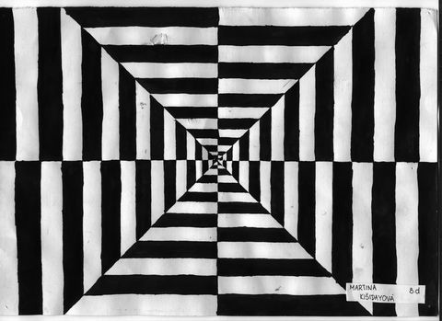
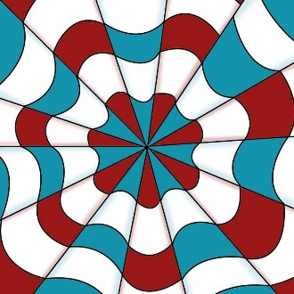
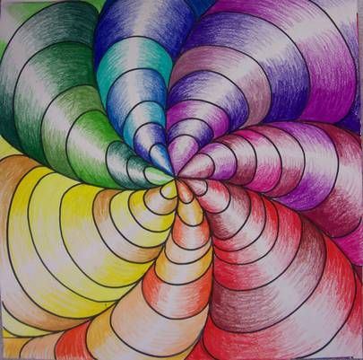

YEAR 6 HOMEWORK

Maths Games and Times table activities:
- http://uk.mathletics.com and then via the ‘sign in’ tab.

- http://www.topmarks.co.uk/maths-games/7-11-years/problem-solving

- http://www.bbc.co.uk/bitesize/ks2/maths/number/

- http://www.crickweb.co.uk/ks2numeracy.html

- www.mathschase.com

- www.timestables.co.uk

Practise your grammar by playing some of these games:
- http://www.bbc.co.uk/bitesize/ks2/english/spelling_grammar/

WW2 Topic activities:

- Build an air raid shelter.
- Research an aircraft, ship or tank that took part in WWII – include a drawing or model with your facts.
- Design and make a game about facts from WWII – board game (snakes and ladders/Monopoly) card game, memory game, observation game.
- Write an adventure story about a child during WWII - include lots of historical references from everything you have learnt this term.
- Use the following link to create a fact file; could be in the form of a leaflet, about WWII
http://www.primaryhomeworkhelp.co.uk/Britain.html
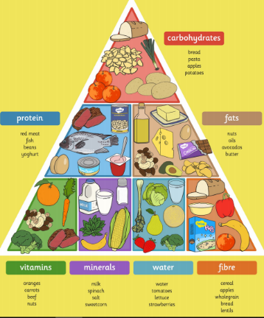
Science:
Create your own heathy living exercise and food plan for an athlete that will be partaking in the 2020 Olympics. Remember to include nutrients from the food pyramid.

